**AIM**: To generate and demodulate a double side band full carrier (DSBFC) signal.

**SOFTWARE USED:** MATLAB & SIMULINK

**PROGRAM:**

clear all;

close all;

fs=1000;

T=1/fs;

t=0:T:pi; %Time Period

fm=1;

fc=100;

am=0.5;

ac=1;

m=(am).*cos(2.*pi.*fm.*t); %Message Signal

c=(ac).*cos(2.*pi.*fc.*t); %Carrier Signal

s0=(ac+m).*cos(2.*pi.*fc.*t); %Under Modulated Signal

subplot(6,1,1);

plot(t,m);

xlabel("time");

ylabel("amplitude");

title("Message Signal(22071A04D4)")

subplot(6,1,2);

plot(t,c);

xlabel("time");

ylabel("amplitude");

title("Carrier Signal(22071A04D4)")

subplot(6,1,3);

plot(t,s0);

xlabel("time");

ylabel("amplitude");

title("Under Modulation Signal(22071A04D4)")

am=1;

ac=1;

m=(am).*cos(2.*pi.*fm.*t); %Message Signal

s=(ac+m).*cos(2.*pi.*fc.*t); %Critical Modulated Signal

subplot(6,1,4);

plot(t,s);

xlabel("time");

ylabel("amplitude");

title("Critical Modulation Signal(22071A04D4)")

am=1;

ac=0.5;

m=(am).*cos(2.*pi.*fm.*t); %Message Signal

s1=(ac+m).*cos(2.*pi.*fc.*t); %Over Modulated Signal

subplot(6,1,5);

plot(t,s1);

xlabel("time");

ylabel("amplitude");

title("Over Modulation Signal(22071A04D4)")

d = s0.*c;

[a,b]=butter(2,(2*fm)/fc);

dmod = filter(a,b,d);

subplot(6,1,6);

plot(t,dmod);

xlabel("time");

ylabel("amplitude");

title("Demodulated Signal(22071A04D4)");

**SIMULINK:**

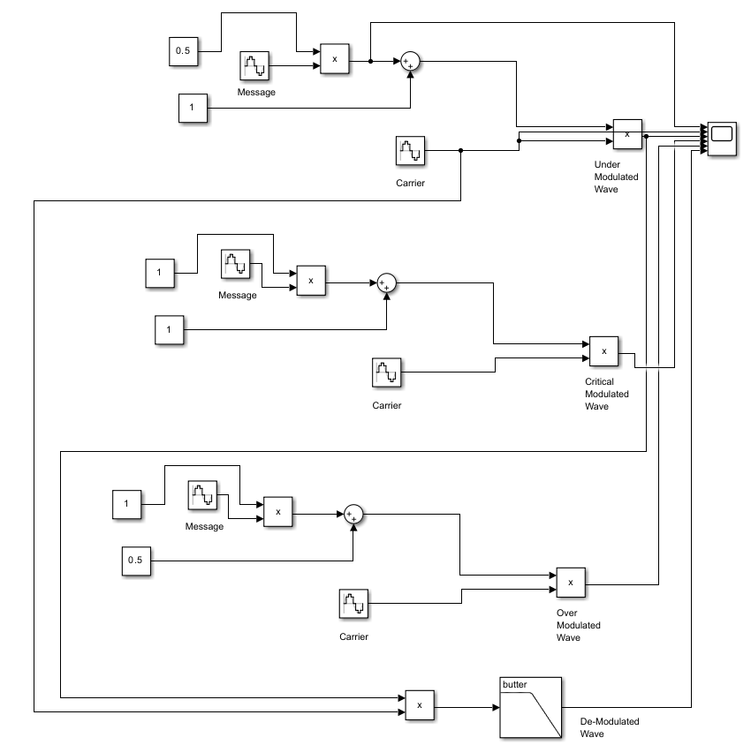**WAVEFORM:**

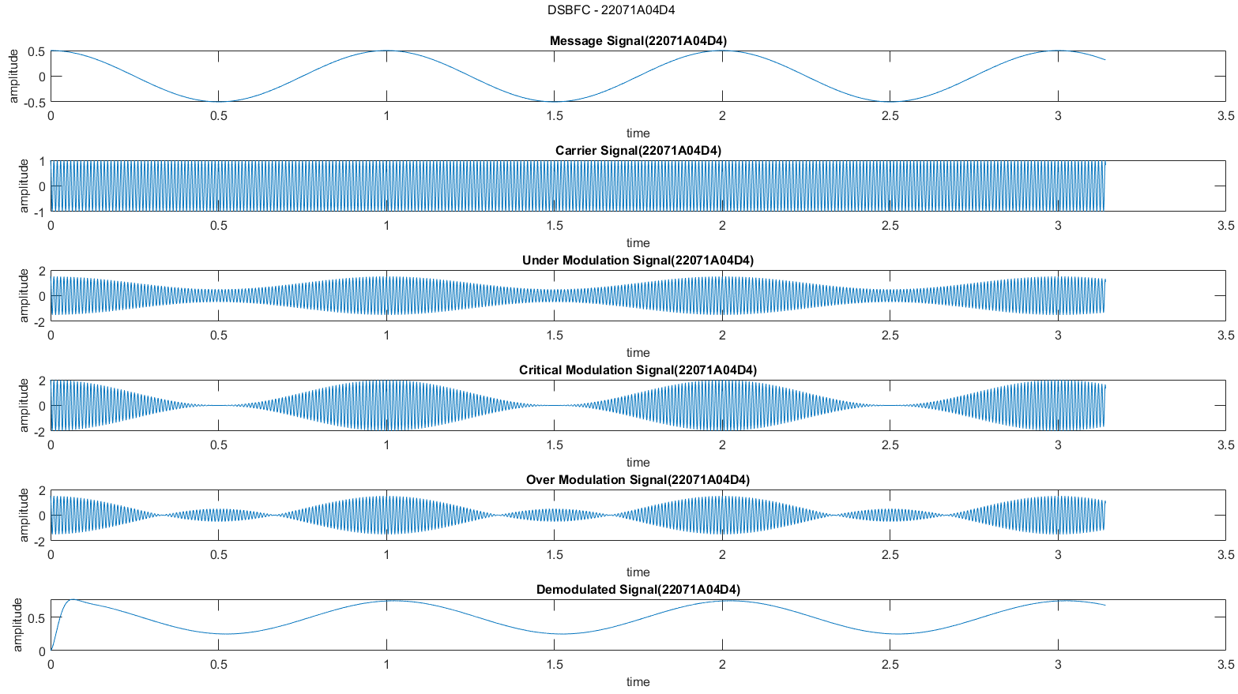

**WAVEFORM[SIMULINK]:**

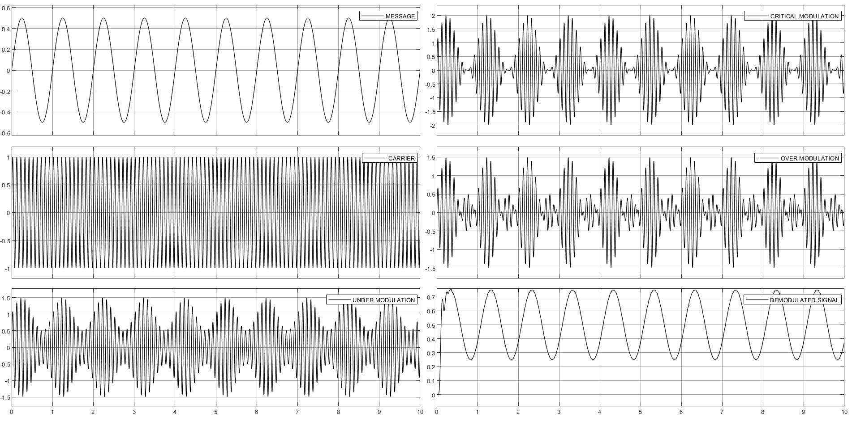

**RESULT:** Hence, Generated and Demodulated a DSBFC Signal using MATLAB & SIMULINK.

**AIM**: To generate and demodulate a double side band suppressed carrier (DSBSC) signal.

**SOFTWARE USED:** MATLAB & SIMULINK

**PROGRAM:**

clear all;

close all;

t = -5:0.01:5; %Time Period

fm=1;

fc=10;

m = sin(2*pi*fm*t); %Message Signal

c = sin(2*pi*fc*t); %Carrier Signal

s = m.*c; %DSBSC Modulated Signal

subplot(4,1,1);

plot(t,m);

xlabel("time");

ylabel("amplitude");

title("Message Signal(22071A04D4)");

subplot(4,1,2);

plot(t,c);

xlabel("time");

ylabel("amplitude");

title("Carrier Signal(22071A04D4)");

subplot(4,1,3);

plot(t,s);

xlabel("time");

ylabel("amplitude");

title("Modulated Signal(22071A04D4)");

d = s.*c;

[a,b]=butter(5,fm/fc/2);

dmod = filter(a,b,d);

subplot(4,1,4);

plot(t,dmod);

xlabel("time");

ylabel("amplitude");

title("Demodulated Signal(22071A04D4)");

sgtitle("DSBSC - 22071A04D4");

fontsize(12,"points");

**SIMULINK:**

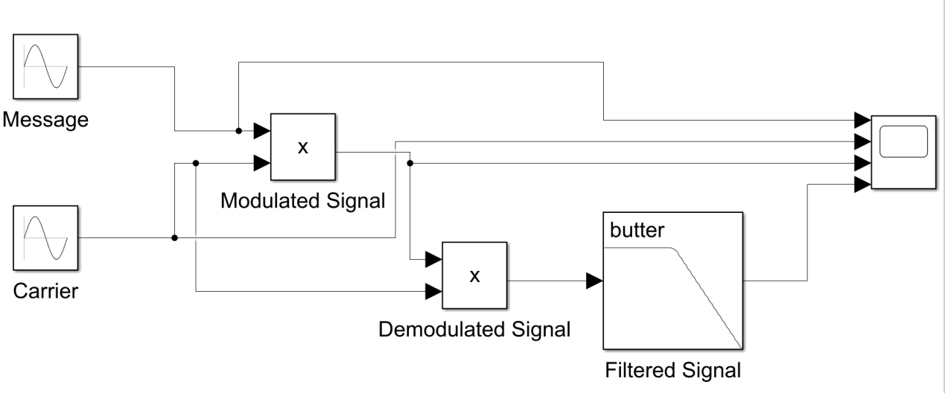

**WAVEFORM:**

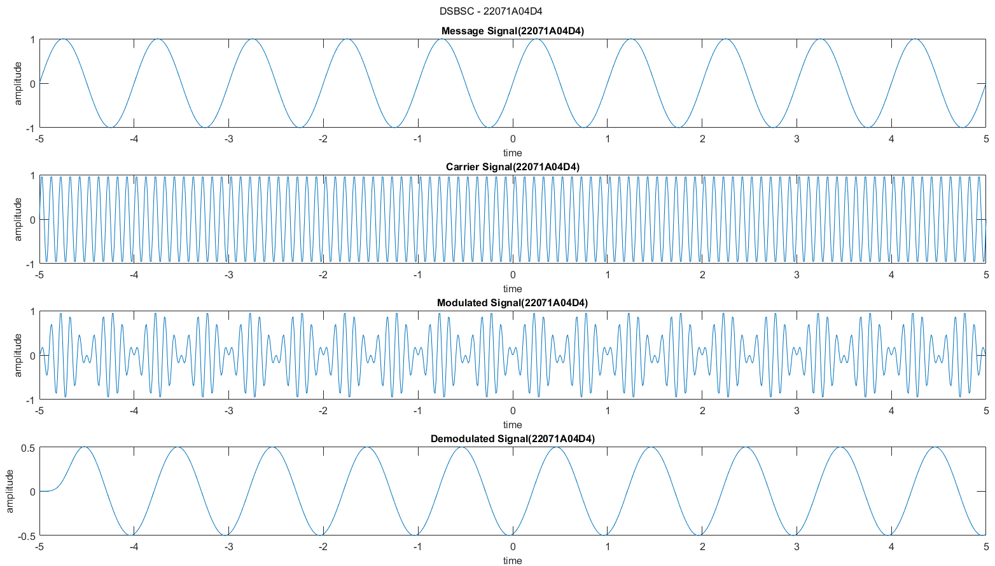

**WAVEFORM[SIMULINK]:**

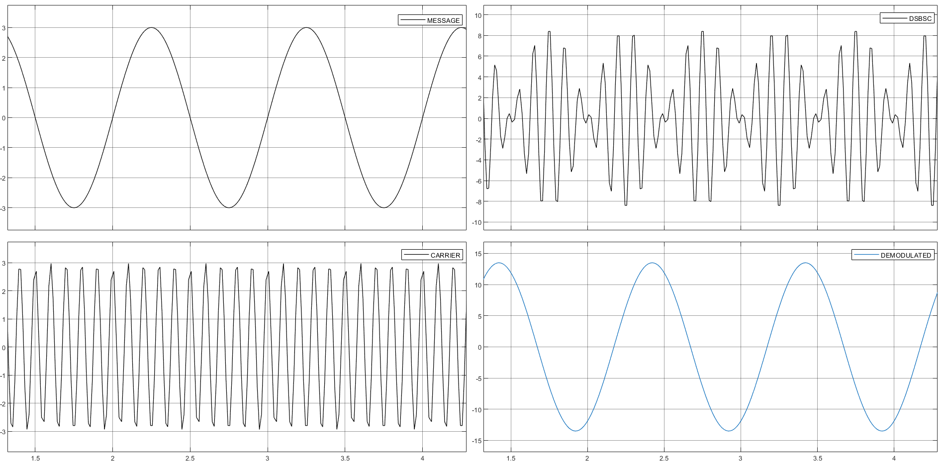

**RESULT:** Hence, Generated and Demodulated a DSBSC Signal using MATLAB & SIMULINK.

**AIM**: To generate and demodulate a single side band suppressed carrier (SSBSC) signal.

**SOFTWARE USED:** MATLAB & SIMULINK

**PROGRAM:**

clear all;

close all;

fm=10;

fc=100;

fs=1000;

t=0:1/fs:1; %Time Period

m=cos(2*pi*fm.*t); %Message Signal with 0 phase shift

mc=sin(2*pi*fm.*t); %Message Signal with 90 phase shift

c=cos(2*pi*fc.*t); %Carrier Signal with 0 phase shift

cc=sin(2*pi*fc.*t); %Carrier Signal with 90 phase shift

fx=m.*c; %DSBSC Signal

fy=mc.*cc; %DSBSC Signal

s1 = fx-fy; %LSB Signal

s2 = fx+fy; %USB Signal

subplot(3,1,1);

plot(t,m);

xlabel("time");

ylabel("amplitude");

title("Message Signal-4D4");

subplot(3,1,2);

plot(t,mc);

xlabel("time");

ylabel("amplitude");

title("Message Signal with phaseshift-4D4");

subplot(3,1,3);

plot(t,c);

xlabel("time");

ylabel("amplitude");

title("Carrier Signal-4D4");

sgtitle("SSBSC - 22071A04D4");

fontsize(12,"points");

figure;

subplot(3,1,1);

plot(t,cc);

xlabel("time");

ylabel("amplitude");

title("Carrier Signal with phaseshift-4D4");

subplot(3,1,2);

plot(t,fx);

xlabel("time");

ylabel("amplitude");

title("DSBSC Signal(fx)");

subplot(3,1,3);

plot(t,fx);

xlabel("time");

ylabel("amplitude");

title("DSBSC Signal(fy)");

fontsize(12,"points");

figure;

subplot(3,1,1);

plot(t,s1);

xlabel("time");

ylabel("amplitude");

title("Lower Side Band Signal-4D4");

subplot(3,1,2);

plot(t,s2);

xlabel("time");

ylabel("amplitude");

title("Upper Side Band Signal-4D4");

d=s1.*cos(2*pi*fc.*t);

[b,a]=butter(5,fm/(fs/2));

demod=filter(b,a,d);

subplot(3,1,3);

plot(t,demod);

xlabel("time");

ylabel("amplitude");

title("Demodulated Signal-4D4");

fontsize(12,"points");

**SIMULINK:**

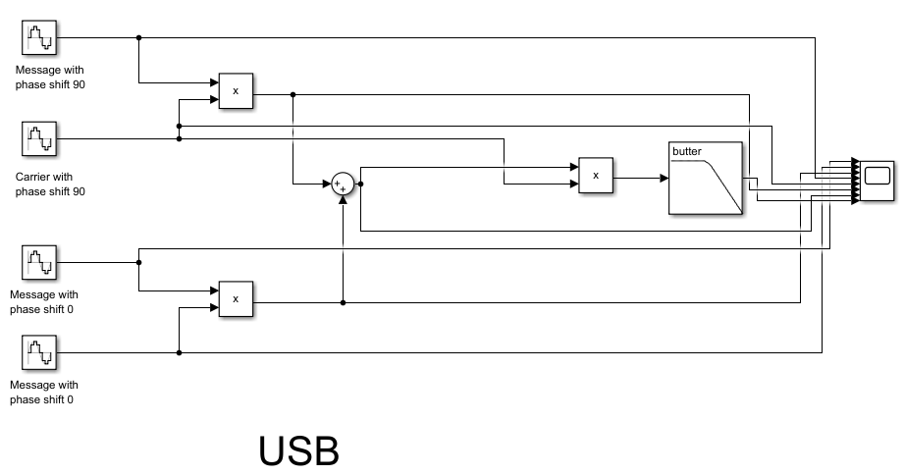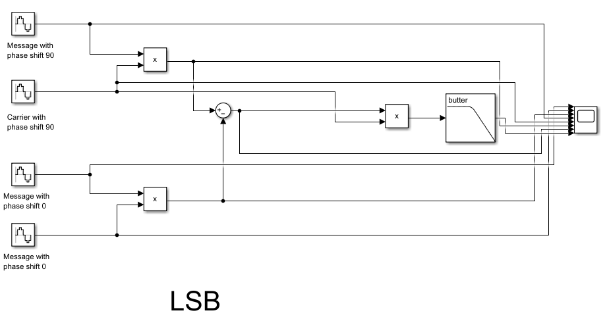

**WAVEFORM:**

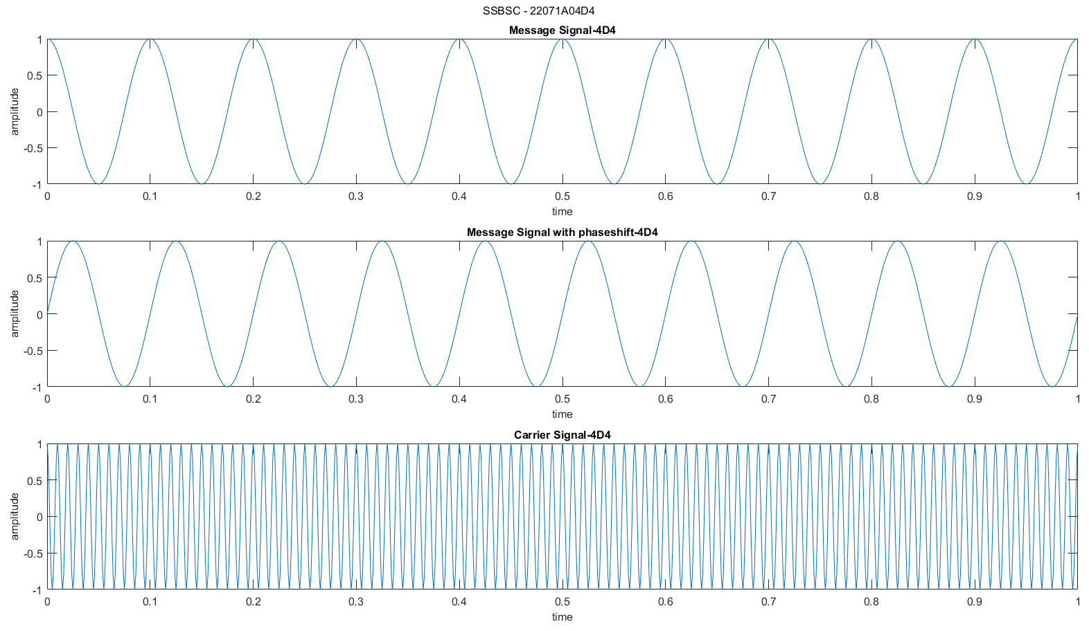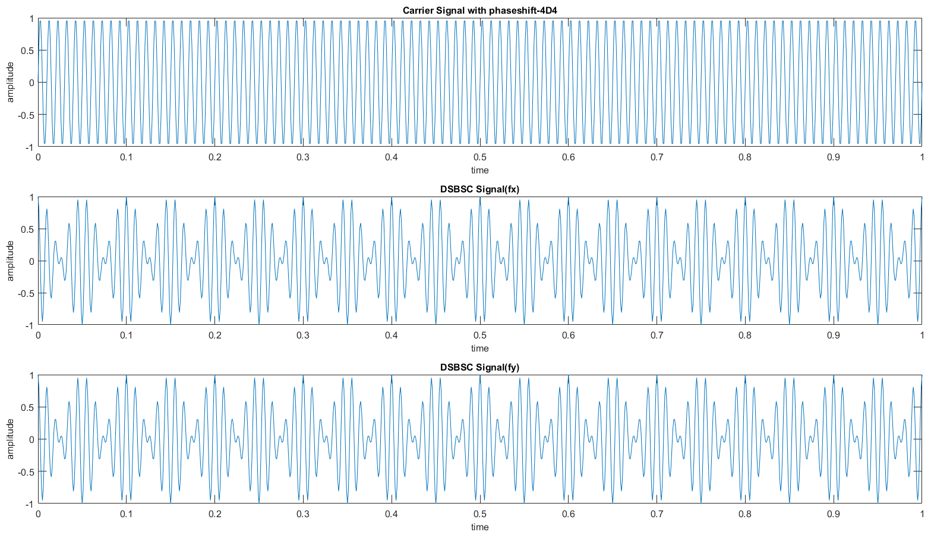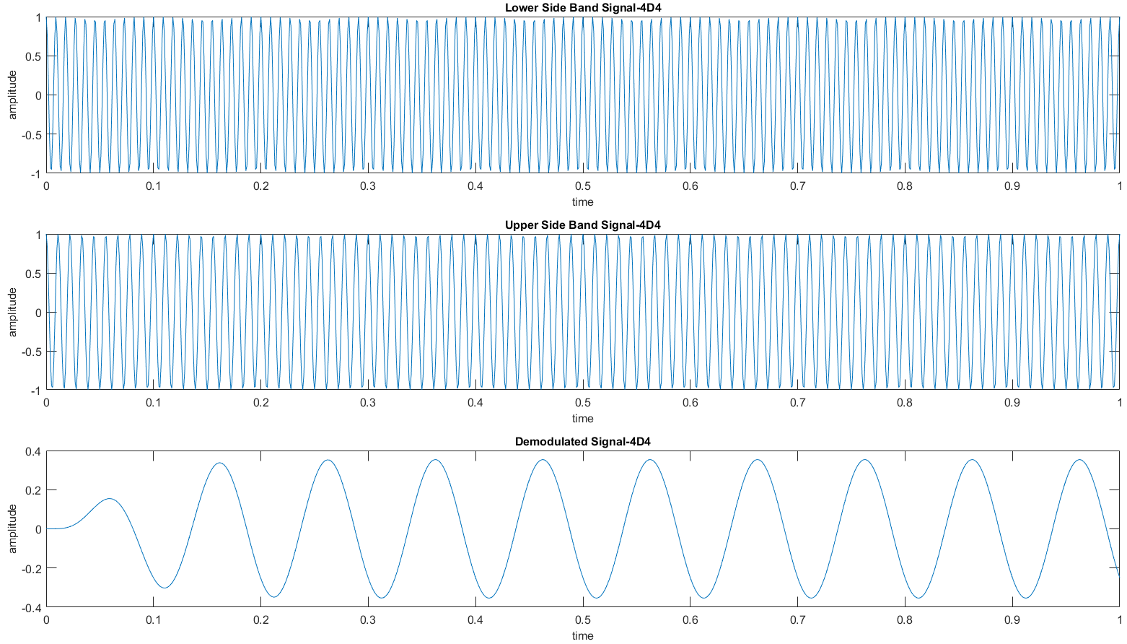

**WAVEFORM[SIMULINK]:**

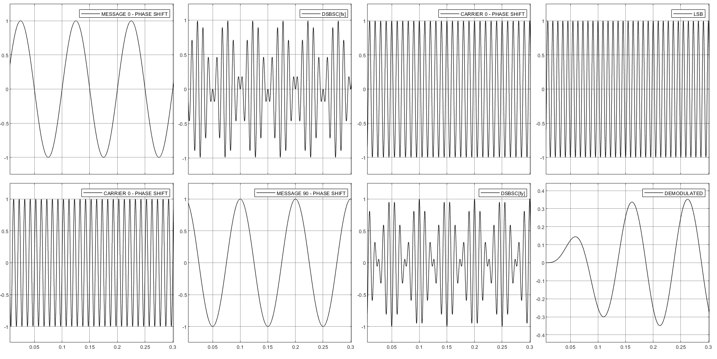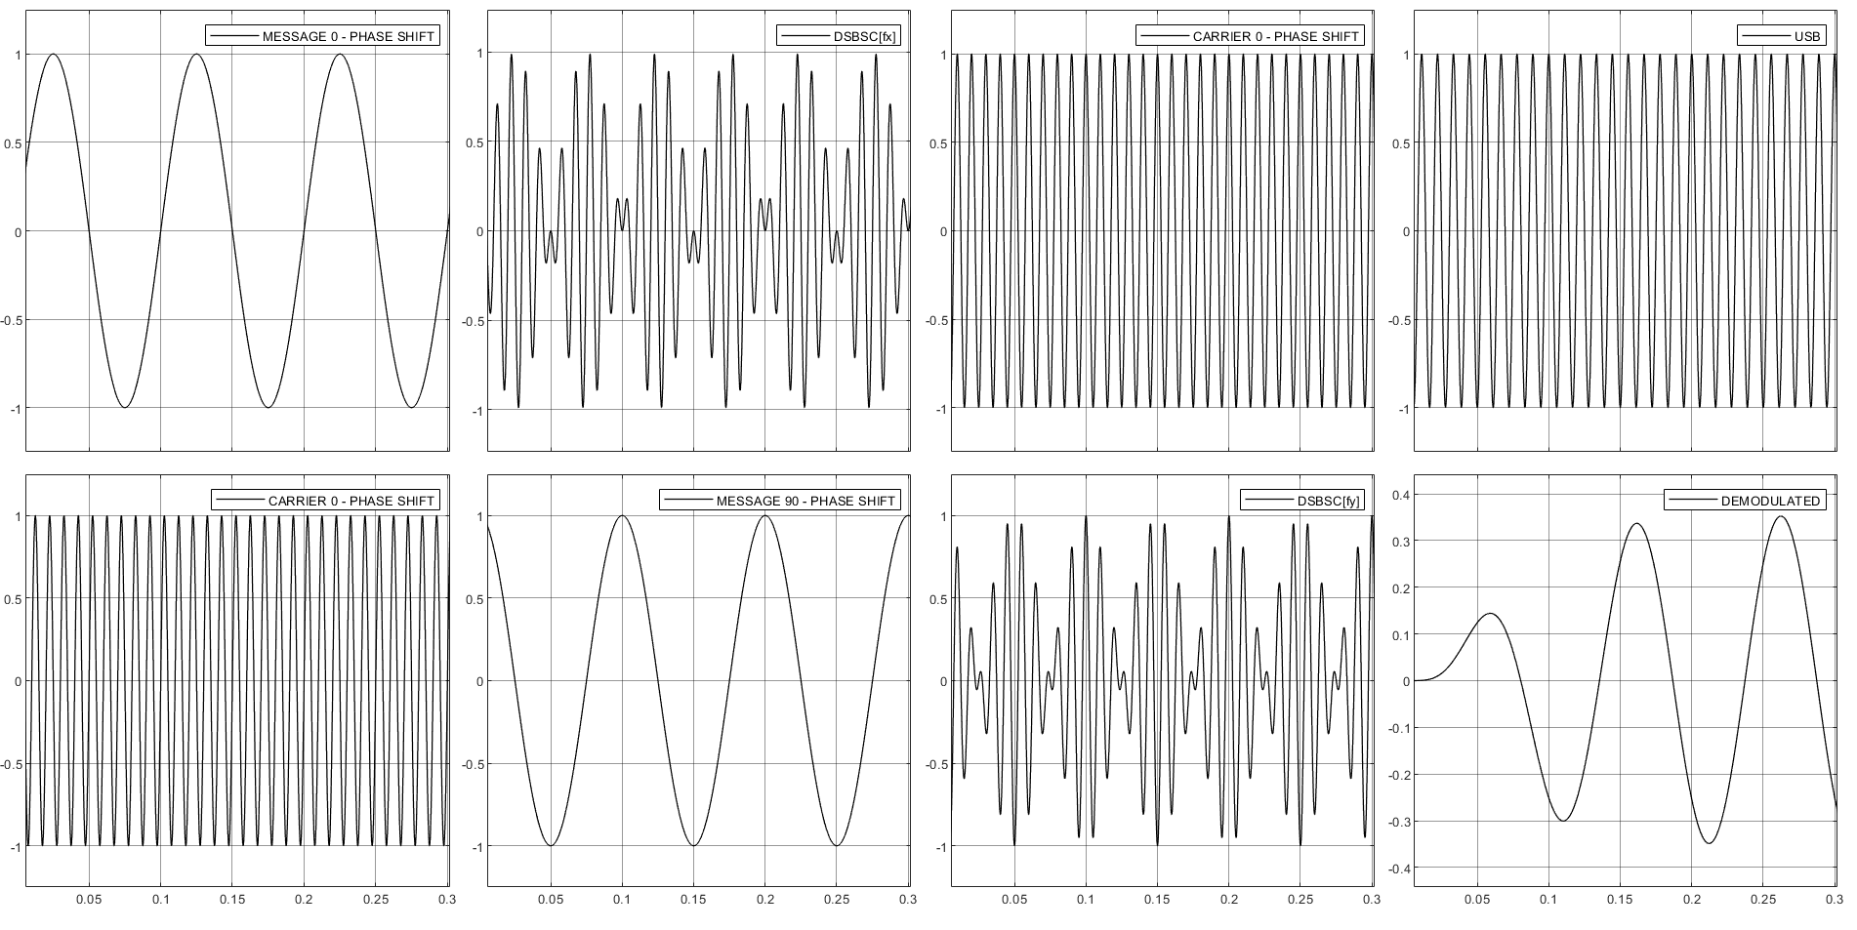

**RESULT:** Hence, Generated and Demodulated a SSBSC Signal using MATLAB & SIMULINK.

**AIM**: To generate and demodulate a frequency modulated signal.

**SOFTWARE USED:** MATLAB & SIMULINK

**PROGRAM:**

close all;

clear all;

fs = 1000;

t = 0:1/fs:2; %Time Period

ac = 1;

am = 1;

fc = 10;

fm = 1;

wc = 2*pi*fc;

wm = 2*pi*fm;

c = ac.*cos(wc.*t); %Carrier Signal

m = am.*sin(wm.*t); %Message Signal

subplot(3,2,1);

plot(t,m);

title("Message Signal-22071A04D4");

ylabel('amplitude');

xlabel("time");

subplot(3,2,2);

plot(t,c);

title("Carrier Signal-22071A04D4");

ylabel('amplitude');

xlabel("time");

b = 0.5;

s1 = ac.*cos(wc.*t +b.*m); %Single Tone FM(Narrow Band)

subplot(3,2,3);

plot(t,s1);

title("Narrow Band FM-22071A04D4");

ylabel('amplitude');

xlabel("time");

b = 5;

s2 = ac.*cos(wc.*t +b.*m); %Single Tone FM(Wide Band)

subplot(3,2,4);

plot(t,s2);

title("Wide Band FM-22071A04D4");

ylabel('amplitude');

xlabel("time");

%demodulation - narrow band fm

d = s1.* c;

d1 = fmdemod(s1,fc,fs,fc+2);

[b,a] = butter(2,2*fm/fs);

z = filter(b,a,d1);

subplot(3,2,5)

plot(t,z);

title("Demodulation -Narrow band FM-22071A04D4");

ylabel('amplitude');

xlabel("time");

%demodulation - wide band fm

d = s2.* c;

d2 = fmdemod(s2,fc,fs,fc+2);

[b,a] = butter(2,2*fm/fs);

z = filter(b,a,d2);

subplot(3,2,6)

plot(t,z);

title("Demodulation - Wide band FM-22071A04D4");

ylabel('amplitude');

xlabel("time");

sgtitle("FM - 22071A04D4")

fontsize(12,"points");

**SIMULINK:**

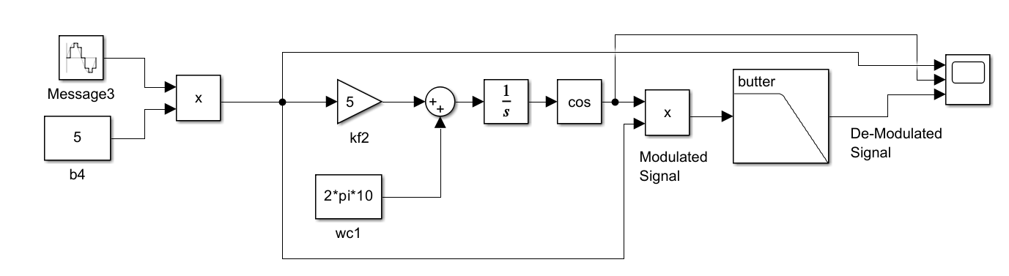

**WAVEFORM:**

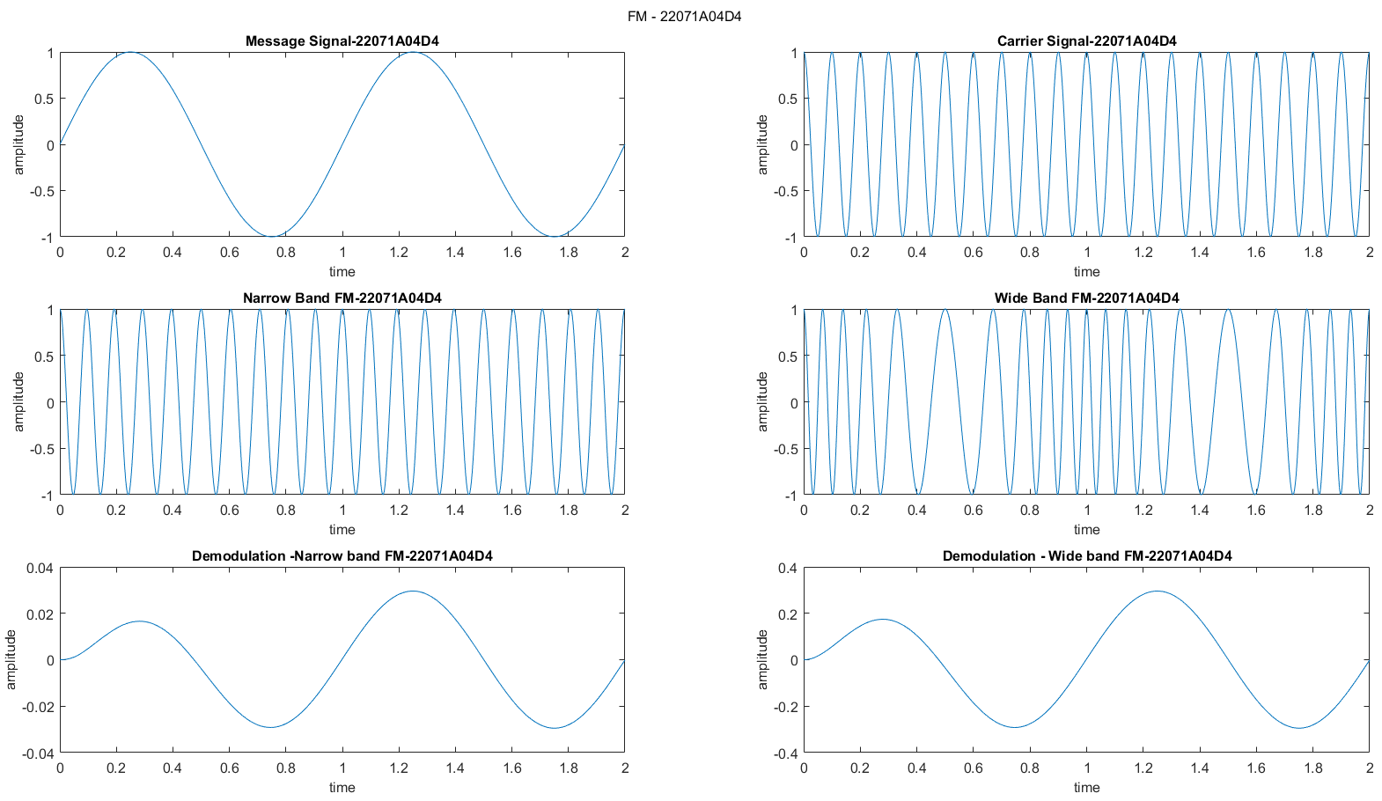

**WAVEFORM[SIMULINK]:**

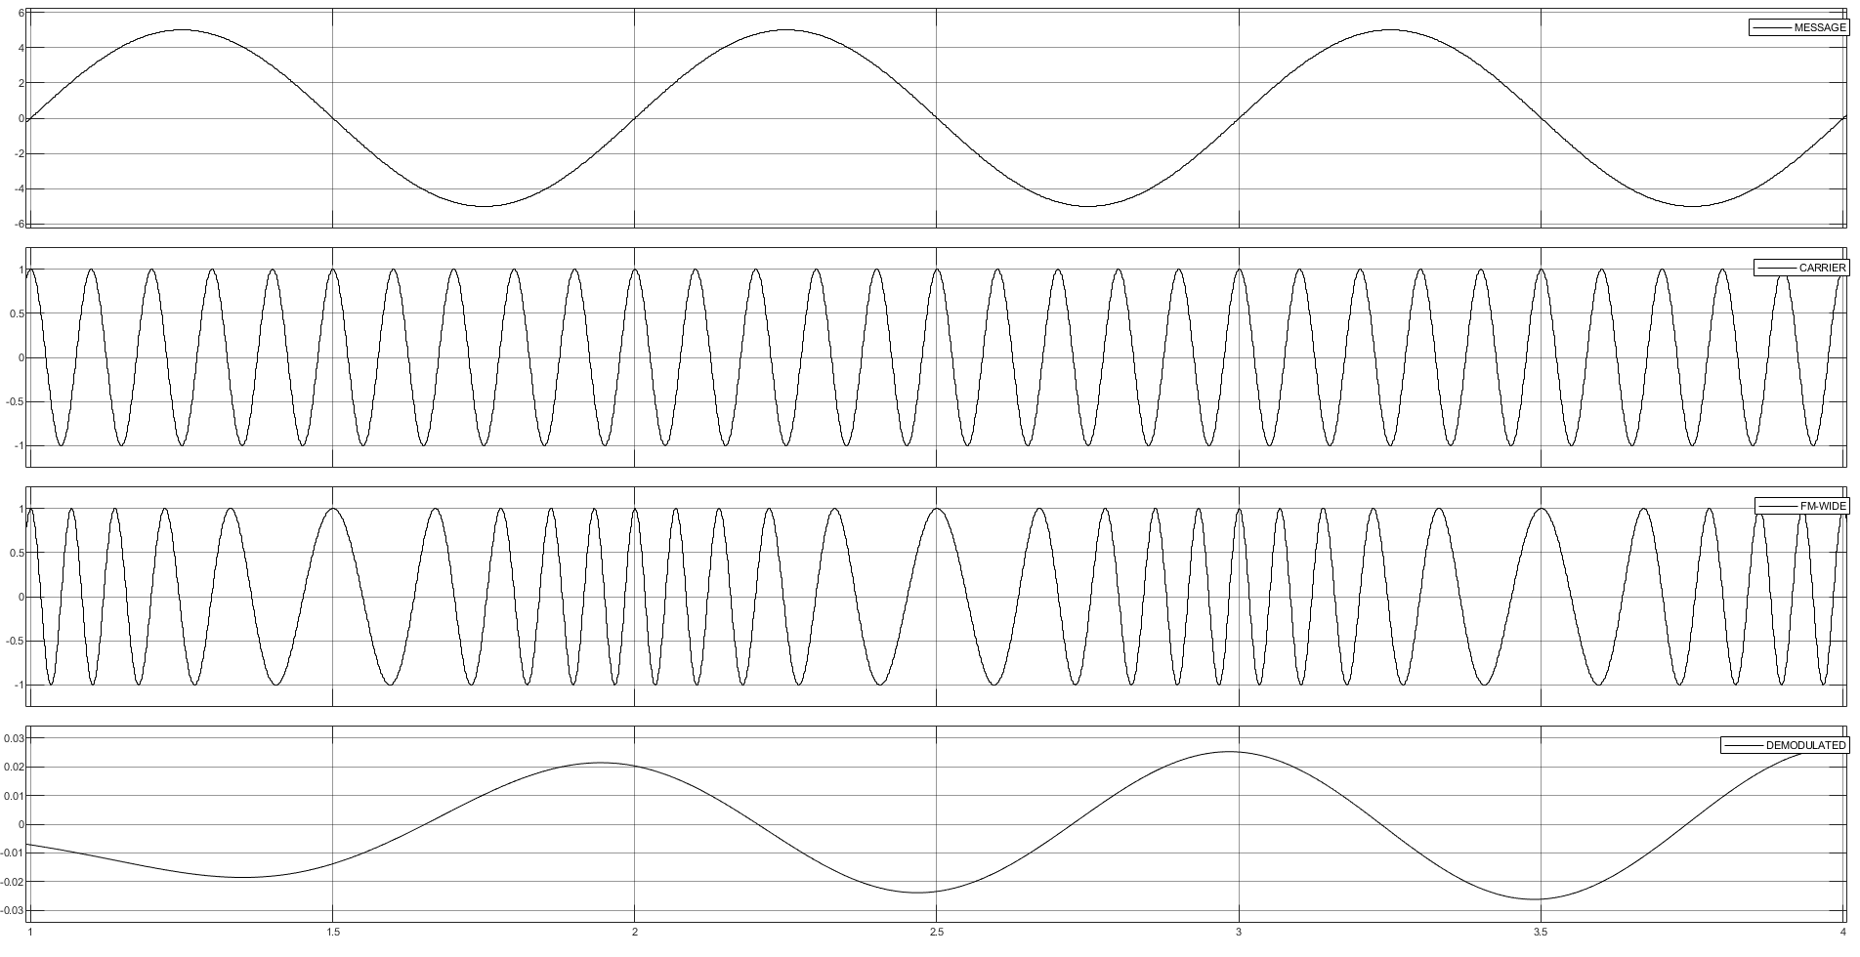

**RESULT:** Hence, Generated and Demodulated a FM Signal using MATLAB & SIMULINK.

**AIM**: To study and verify sampling theorem and reconstruct the sampled waveform.

**SOFTWARE USED:** MATLAB & SIMULINK

**PROGRAM:**

clear all

close all

t=-10:0.01:10; T=4; fm=1/T;

x=sin(pi*fm*t)+cos(2*pi*fm*t);

subplot(3,2,1);

plot(t,x);

xlabel("time");

ylabel("amp");

title("Continuous Time Signal(4D4)");

fs1=1.2*fm;

fs2=2*fm;

fs3=8*fm;

n1=-4:1:4;

x1=sin(pi*fm*n1/fs1)+cos(2*pi*fm*n1/fs1);

subplot(3,2,2);

stem(n1,x1);

hold on;

subplot(3,2,2);

plot(n1,x1);

xlabel("time");

ylabel("amp");

title("Overlap(4D4)");

n2=-5:1:5;

x2=sin(pi*fm*n2/fs2)+cos(2*pi*fm*n2/fs2);

subplot(3,2,3);

stem(n2,x2); hold on;

subplot(3,2,3);

plot(n2,x2);

xlabel("time");

ylabel("amp");

title("Nyquiest(4D4)");

n3=-20:1:20;

x3=sin(pi*fm*n3/fs3)+cos(2*pi*fm*n3/fs3);

subplot(3,2,4);

stem(n3,x3);

hold on

plot(n3,x3);

xlabel("time");

ylabel("amp");

title("Sampling(4D4)");

subplot(3,2,5);

plot(n3,x3);

xlabel("time");

ylabel("amp");

title("Reconstruction(4D4)");

sgtitle("SAMPLING THEOREM - 22071A04D4")

fontsize(12,"points");

**SIMULINK:**

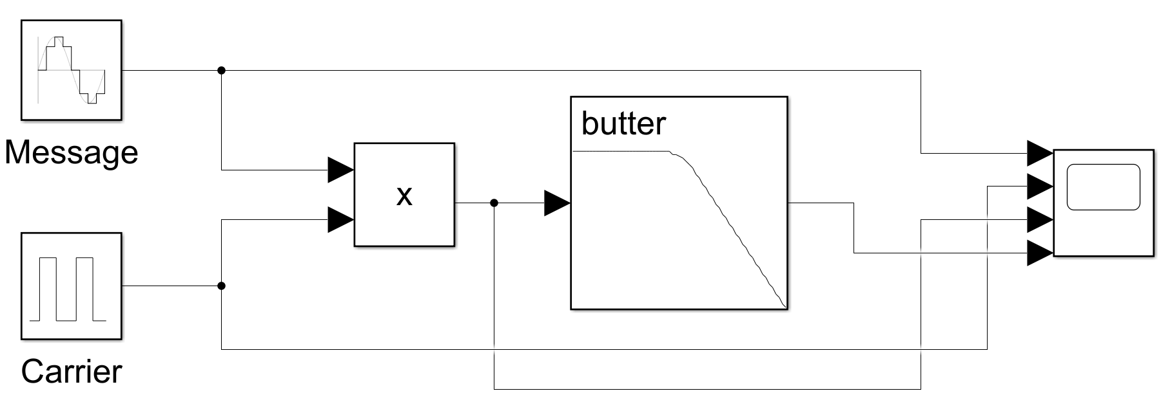

**WAVEFORM:**

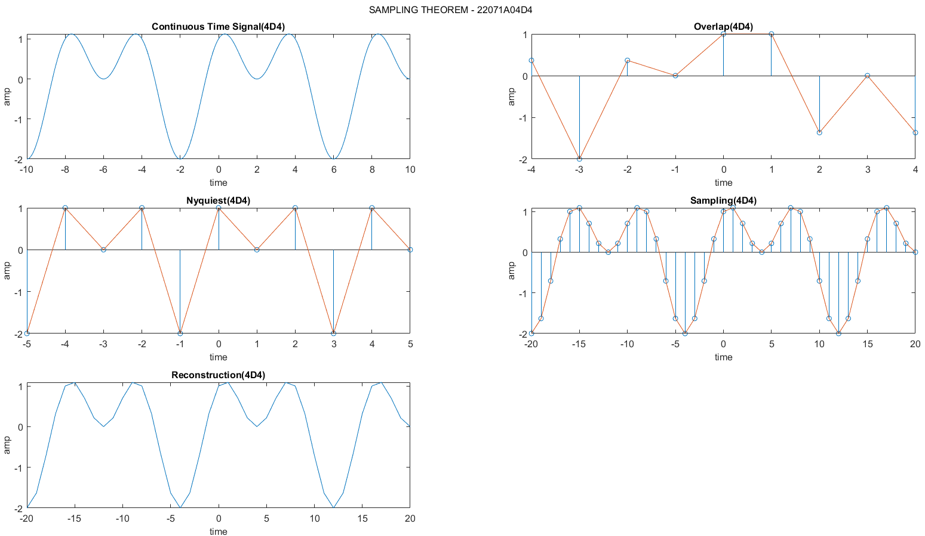

**WAVEFORM[SIMULINK]:**

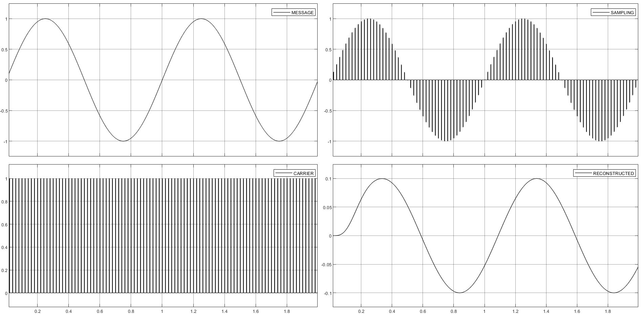

**RESULT:** Hence, the message signal is converted to samples and reconstructed the original signal from the samples.

**AIM**: To generate and demodulate a pulse amplitude modulated signal.

**SOFTWARE USED:** MATLAB & SIMULINK

**PROGRAM:**

fs=1000;

T=1/fs;

t=0:T:pi; %Time Period

a=1;

fm=1;

fc=10;

c = 0.5.*square(2*pi*fc.*t)+0.5;

m = a.*sin(2*pi*fm.*t);

y = m.*c;

u=[];

for i=1:length(y)

if y(i)==0

u=[u,y(i)];

else

u=[u,y(i)+2];

end

end

dmod = y.*c;

filter = fir1(200,fm/fs,'low');

og = conv(filter,dmod);

subplot(5,1,1);

plot(t,m);

xlabel('Time');

ylabel('Amplitude');

title('Sinusoidal Signal-22071A04D4');

subplot(5,1,2);

plot(t,c);

xlabel('Time');

ylabel('Amplitude');

title('Carrier Signal-22071A04D4');

axis([min(t),max(t), min(c)-0.5,max(c)+0.5]);

subplot(5,1,3);

plot(t,y);

xlabel('Time');

ylabel('Amplitude');

title('PAM Bipolar Waveform-22071A04D4');

axis([min(t),max(t), min(y)-0.2,max(y)+0.2]);

subplot(5,1,4);

plot(t,u);

xlabel('Time');

ylabel('Amplitude');

title('PAM Unipolar Waveform-22071A04D4');

axis([min(t),max(t), min(u),max(u)+0.5]);

t=0:1/((length(og))-1):1;

subplot(5,1,5);

plot(t,og);

xlabel('Time');

ylabel('Amplitude');

title('PAM Demodulated Waveform-22071A04D4');

sgtitle("PAM - 22071A04D4")

fontsize(12,"points");

**SIMULINK:**

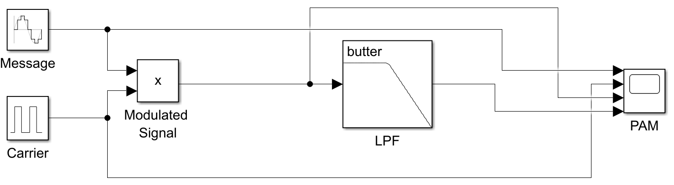

**WAVEFORM:**

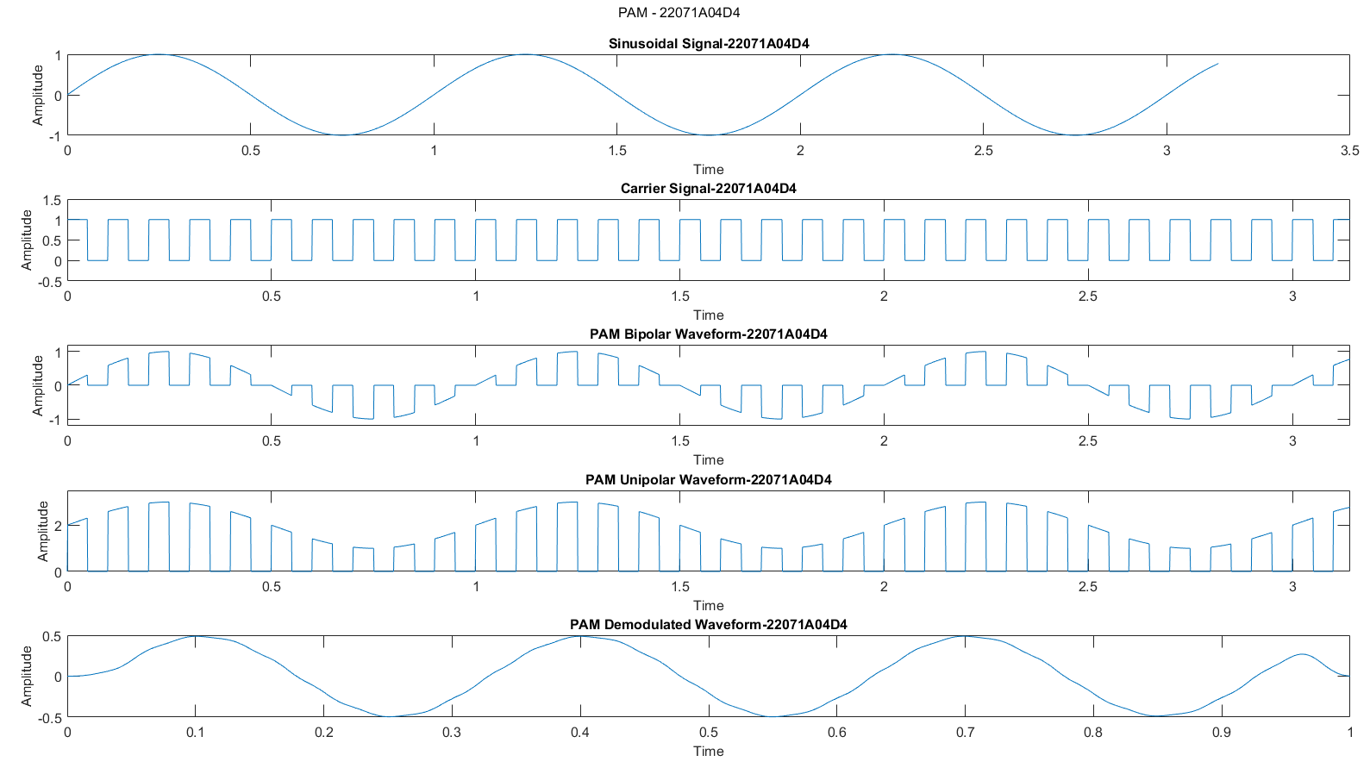

**WAVEFORM[SIMULINK]:**

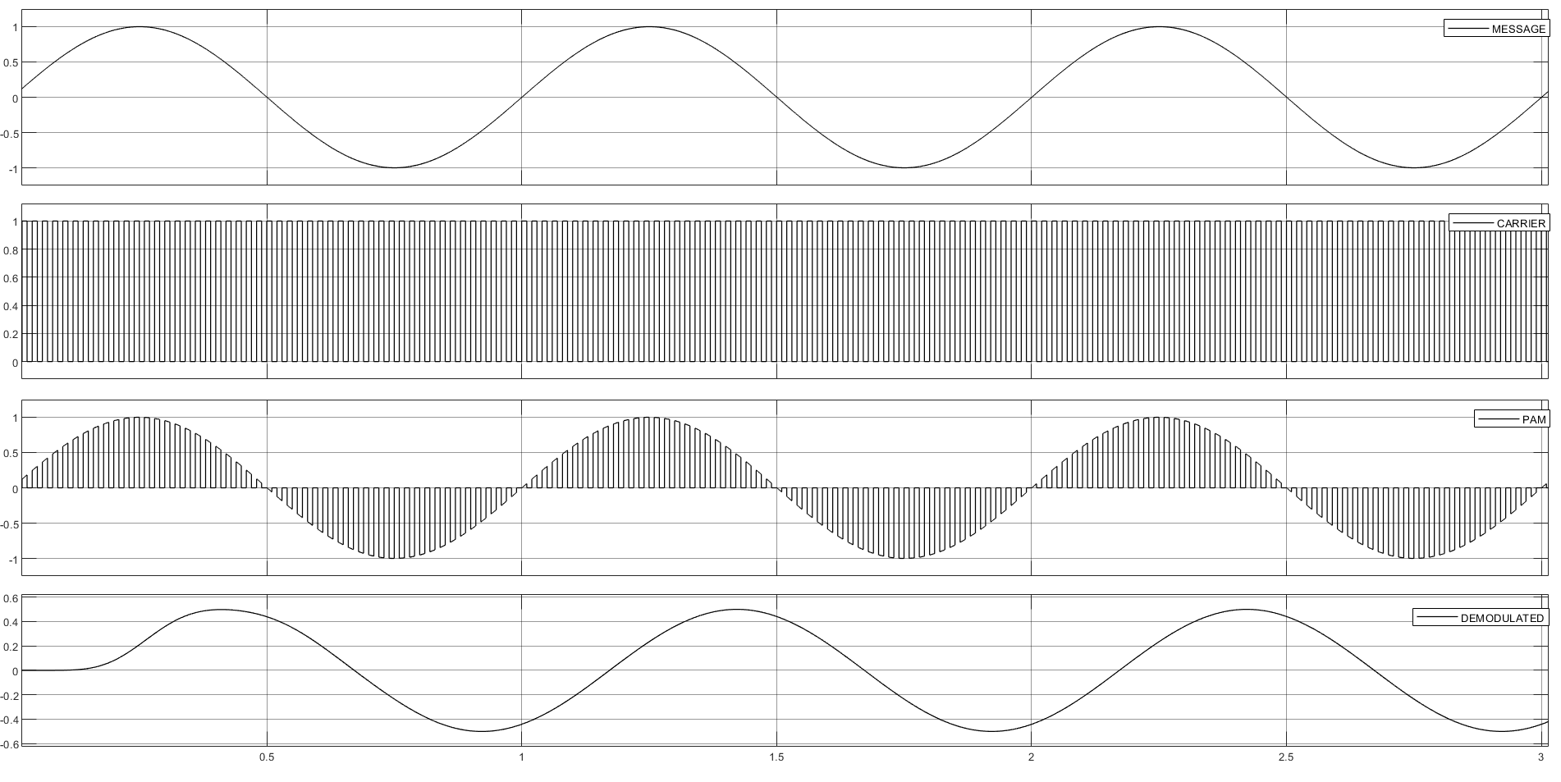

**RESULT:** Hence, Generated and Demodulated a PAM Signal using MATLAB & SIMULINK.

**AIM**: To generate and demodulate a pulse width modulated signal.

**SOFTWARE USED:** MATLAB & SIMULINK

**PROGRAM:**

close all;

clear all;

fs=1000;

T=1/fs;

t=0:T:2*pi; %Time Period

fc = 10;

fm = 1;

c = sawtooth(2*pi*fc.*t);

m=cos(2*pi*fm.*t);

n=length(c);

for i=1:n

if (m(i)-c(i)>=0)

pwm(i)=1;

elseif (m(i)-c(i)<=0)

pwm(i)=0;

end

end

subplot(4,1,1);

plot(t,m);

xlabel('Time');

ylabel('Amplitude');

title('Message Signal(4D4)');

axis([0 2 min(m)-0.5 max(m)+0.5]);

subplot(4,1,2);

plot(t,c);

xlabel('Time');

ylabel('Amplitude');

title('Carrier Signal(4D4)');

axis([0 2 min(c)-0.5 max(c)+0.5]);

subplot(4,1,3);

plot(t,pwm);

xlabel('Time');

ylabel('Amplitude');

title('PWM Signal(4D4)');

axis([0 2 min(pwm)-0.5 max(pwm)+0.5]);

demoddi=demod(pwm,fc,fs,'pwm');

subplot(4,1,4);

plot(demoddi);

title('PWM Demod(4D4)');

xlabel('Time');

ylabel('Amplitude');

axis([0 20 min(demoddi)-0.5 max(demoddi)+0.5]);

sgtitle("PWM - 22071A04D4")

fontsize(12,"points");

**SIMULINK:**

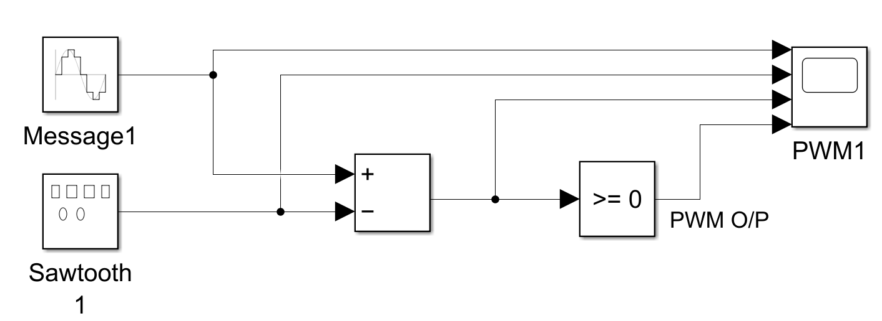

**WAVEFORM:**

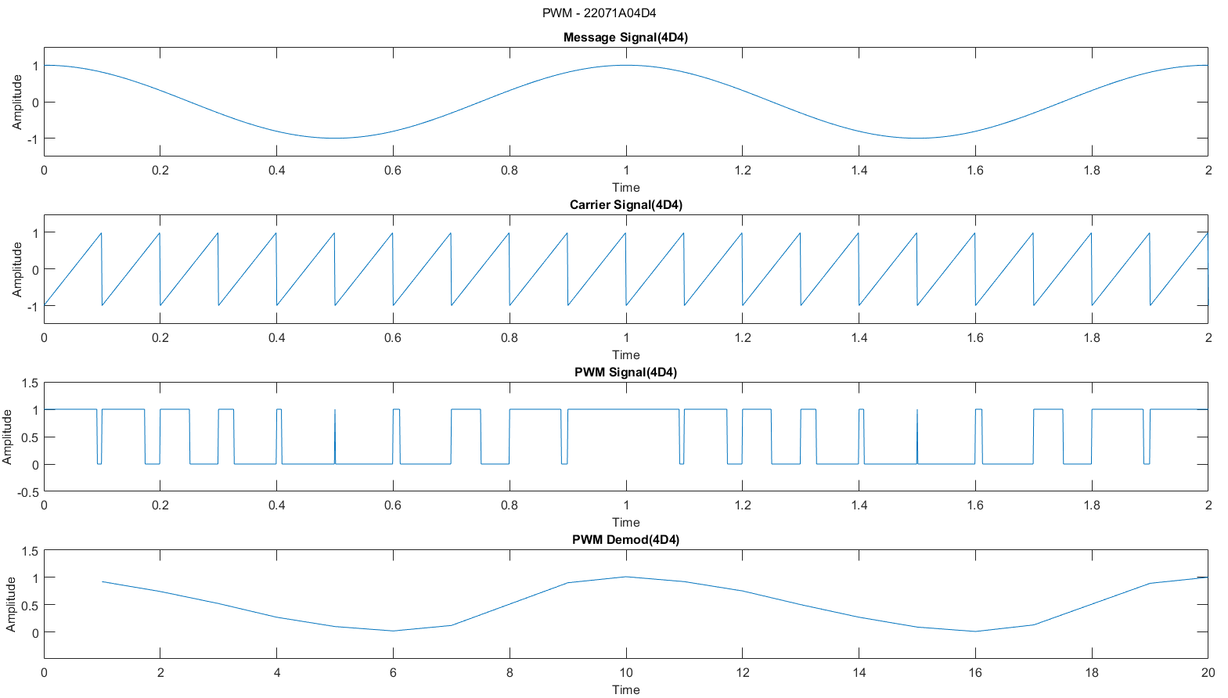

**WAVEFORM[SIMULINK]:**

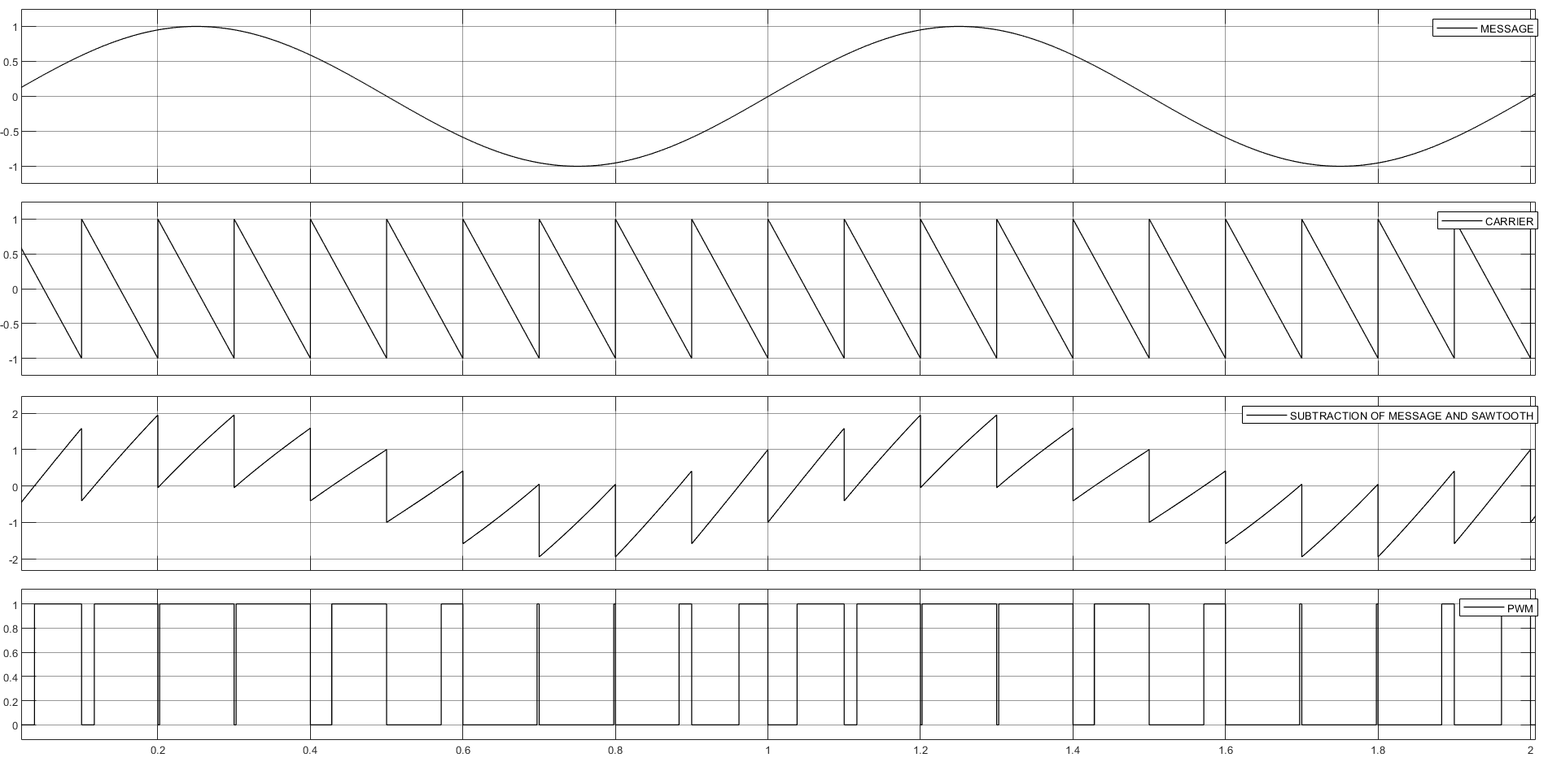

**RESULT:** Hence, Generated and Demodulated a PWM Signal using MATLAB & SIMULINK.